Submitting Assignments

Submitting Assignments

All coding assignments for this course are submitted through the Autograder, which is an external tool hosted at the University of Michigan and linked to the Coursera platform. The first graded assignment is in Week 3.

Select the assignment, then click the **Open Tool** button to go to the Autograder.

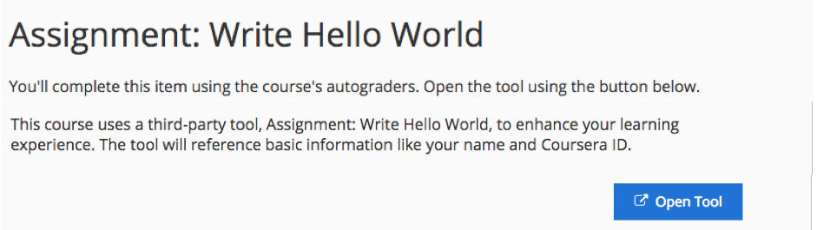

Note: Be sure to accept the Honor Code if you are working toward a Verified Certificate.

Enter your program in the left pane of the window and click **Check Code**.

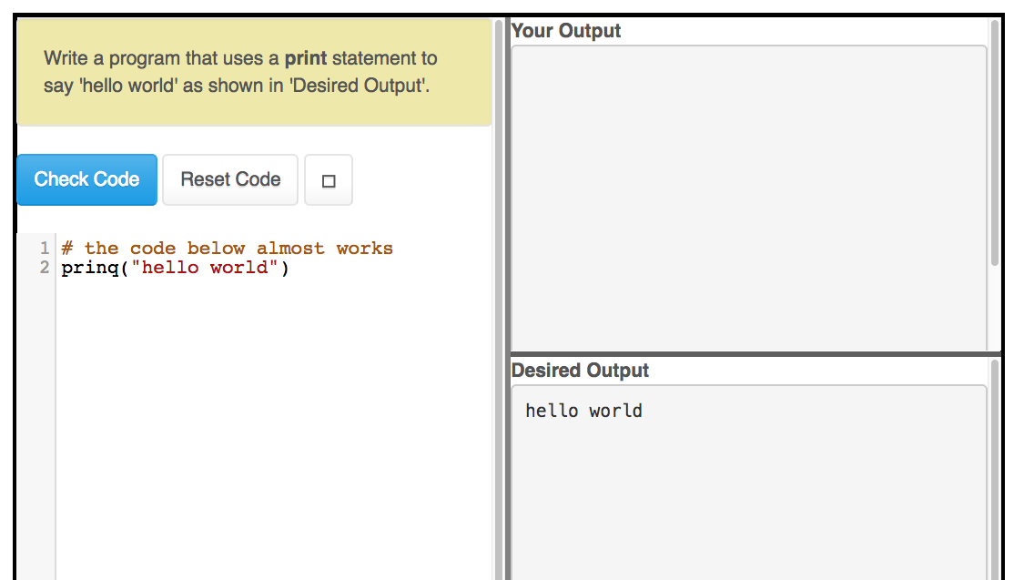

If your code is correct, the Autograder will display the message **Grade updated on server**.

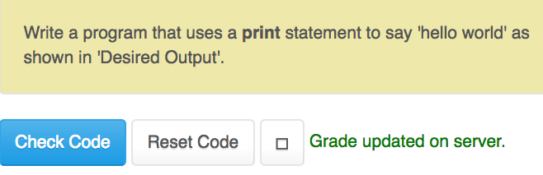

Your output must match the Desired Output ***exactly*** (including capitalization and spaces) for it to be accepted as correct.

Click **Exit** to close the Autograder.

**Grading Notes**

* This course uses Python 3, and the autograder defaults to Python 3. But if you look closely you can switch the autograder to accept Python 2 and submit your assignments in Python 2.
* Assignments are pass/fail. There is no partial credit.
* Once you have passed an assignment, your grade will not be changed by later failed attempts.
* **Reset Code** resets the starter code for the assignment to its original value. This will not affect your recorded grade.
* When you reopen an assignment that you have already passed, your score is displayed.

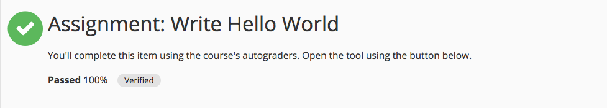

The [Python Code Playground](https://www.coursera.org/learn/python/ungradedLti/LqMCR/python-code-playground-developing-python-in-the-browser) is basically the course Autograder without any grading functions. Type or paste your code in the left side of the window, then press **Check Code**. It's a good place to try things out, or test your scripts before you submit them.